Create a docker image for any application using Docker file and push it to Docker hub

- Create a Instance
—-----------------------------------

- Install nginx, Nodejs, Npm, Pm2
—-----------------------------------------------------------

→ Login in EC2

apt update -y

→ Install Nginx webserver

apt install nginx -y

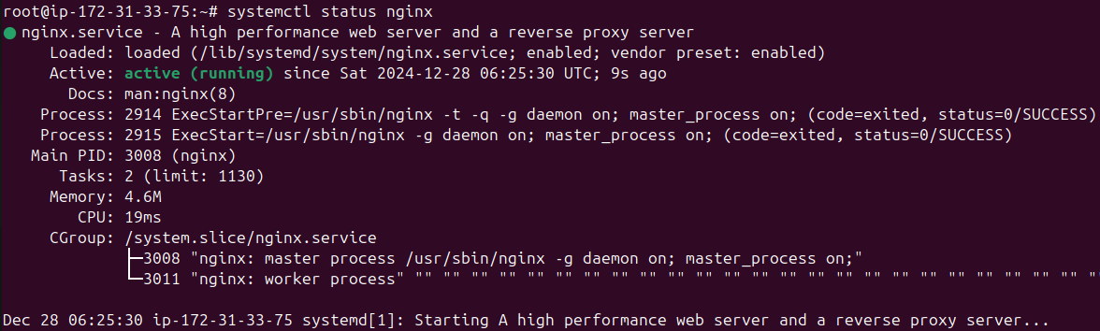

→ Install Nodejs

apt install nodejs -y

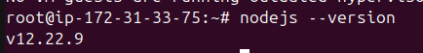

→ Install NPM (node package manager)

apt install npm -y

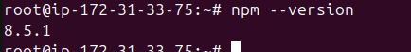

→ Install Pm2 (process manager)

npm install -g pm2
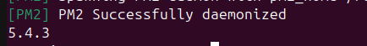

- Creating a Nodejs Application
—--------------------------------------------------------

→First, using nano or your favorite text editor, create a sample application called hello.js inside the home directory

→ Go to the home directory

cd /home

→open a hello.js file and paste the code

nano hello.js
const http = require('http');

const hostname = '0.0.0.0';
const port = 3000;

const server = http.createServer((req, res) => {
res.statusCode = 200;
res.setHeader('Content-Type', 'text/plain');
res.end('Hello World!\n');
});

server.listen(port, hostname, () => {
console.log(`Server running at http://${hostname}:${port}/`);
});

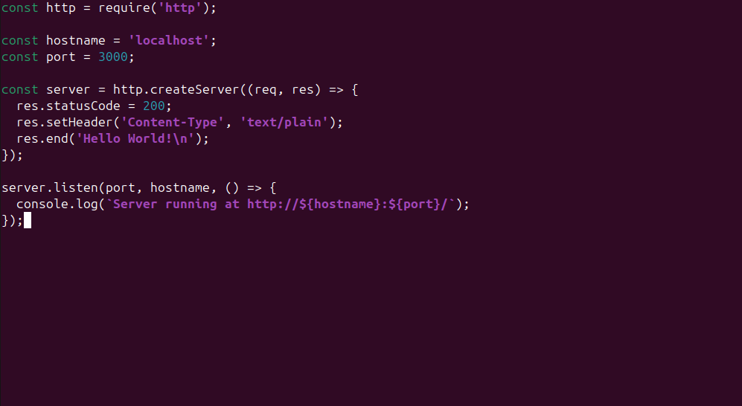

Save the file and exit from the editor

Ctrl + o = saving
Ctrl + x = exit

→ This Node.js application listens on the specified address (0.0.0.0) and port (3000), and returns “Hello World!” with a 200 HTTP success code. Since we’re listening on localhost, remote clients won’t be able to connect to our application.

To test your application, type:

node hello.js

→ Going to start node application in pm2

pm2 start hello.js --name app

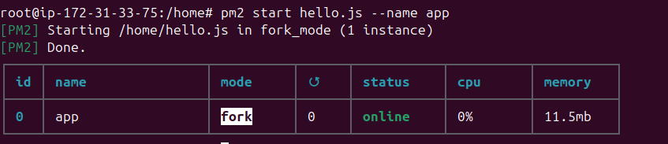

→ Setting up node application in nginx as a reverse proxy

To let Your application is running and listening on localhost, but you need to set up a way for your users to access it. We will set up the Nginx web server as a reverse proxy for this purpose.

In the prerequisite tutorial, you set up your Nginx configuration in the /etc/nginx/sites-available/example.com file. Open this file for editing

nano /etc/nginx/sites-available/example.com

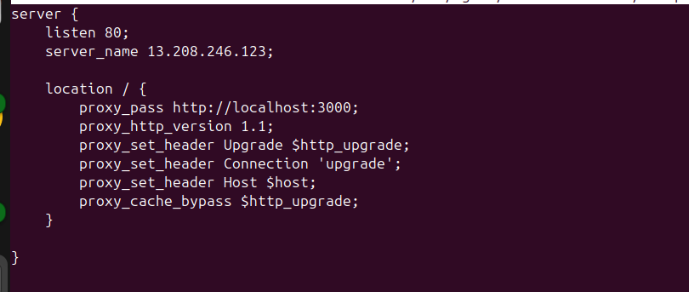

server {
listen 80;
server_name 13.208.246.123;

location / {
proxy_pass http://localhost:3000;
proxy_http_version 1.1;
proxy_set_header Upgrade $http_upgrade;
proxy_set_header Connection 'upgrade';
proxy_set_header Host $host;
proxy_cache_bypass $http_upgrade;
}

}
(replace with your server public ip)

→ Create a symink for this example.com

ln -s /etc/nginx/sites-available/example.com /etc/nginx/sites-enabled/

→ Restart your nginx webserver

systemctl restart nginx

→ Check your application in browser using IP
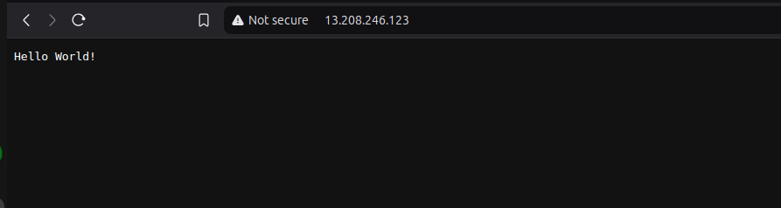

Nodejs application is Running on Ec2 instance

- Settting up in Docker
—------------------------------------
→ Install docker

apt install -y docker.io
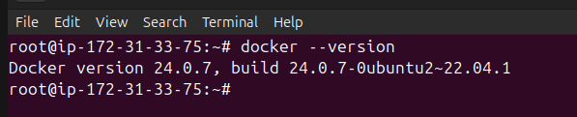

→ Install Docker Compose

apt install -y docker-compose
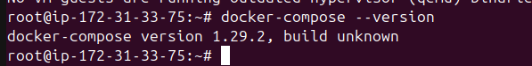

→ Navigate to the application directory

cd /home/ubuntu

nano Dockerfile

→ Create a Dockerfile in the /home/node directory
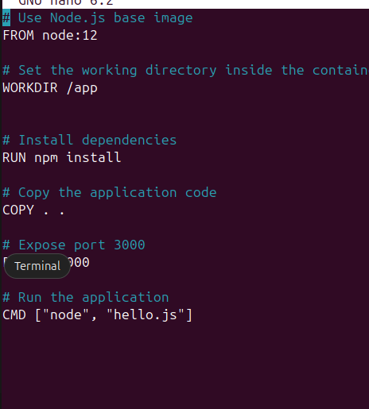

# Use Node.js base image
FROM node:12

# Set the working directory inside the container
WORKDIR /app

# Install dependencies
RUN npm install

# Copy the application code
COPY . .

# Expose port 3000
EXPOSE 3000

# Run the application
CMD ["node", "hello.js"]

Save it and exit from editor

→ Create a .dockerignore File
Create a .dockerignore file to exclude unnecessary files from the image

nano .dockerignore

node_modules
npm-debug.log

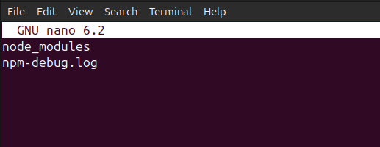
Save it and exit from editor

→ Build the docker image

docker build -t tejaswiakula/node-app:latest .
(Here arunhub01 is my dockerhub username. Replace with your dockerhub username)
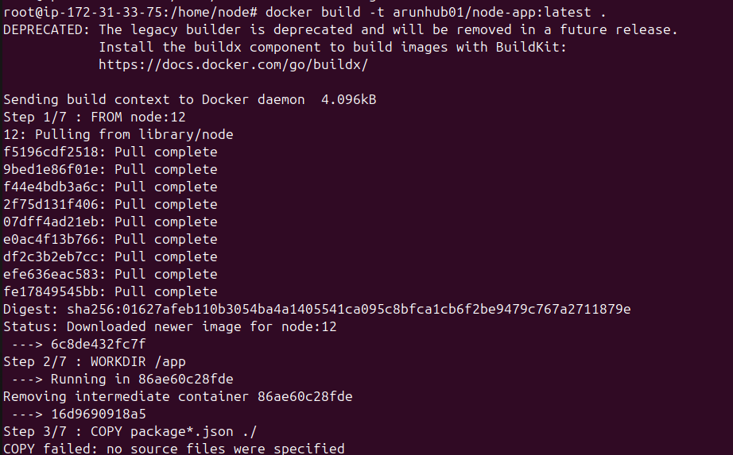
Docker build the image is completed

→ Verify the image is build or not

docker images

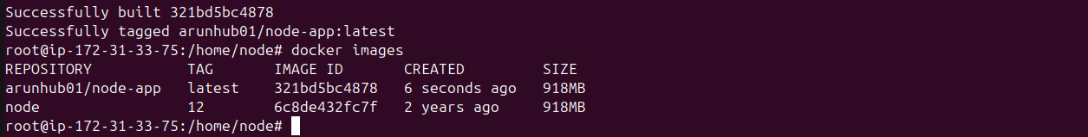

- Push the image to Docker Hub
—-------------------------------------------------
→ Log in to Docker Hub

docker login
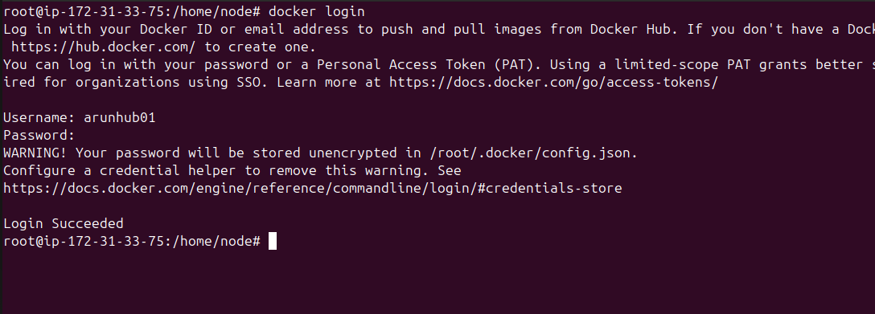
When you use docker login command, you were asked by username and password. Please enter correct username and password of your dockerhub.

→ Push the image to docker hub

docker push tejaswiakula/node-app:latest
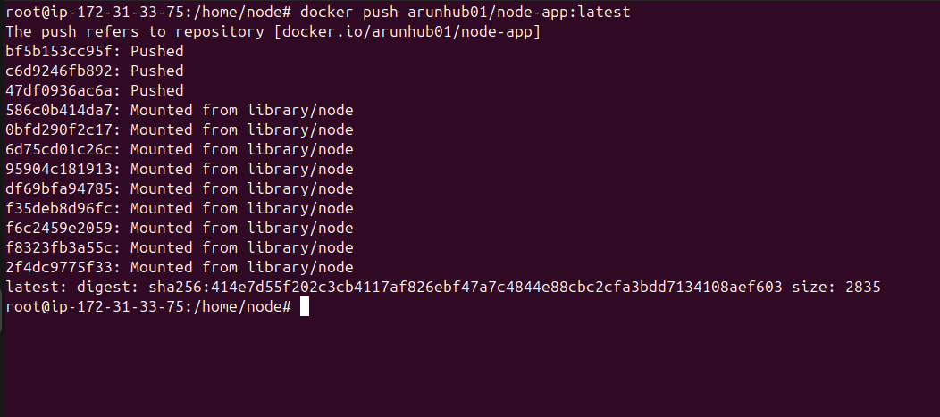

→ Go to the Docker hub and check repo is there or not
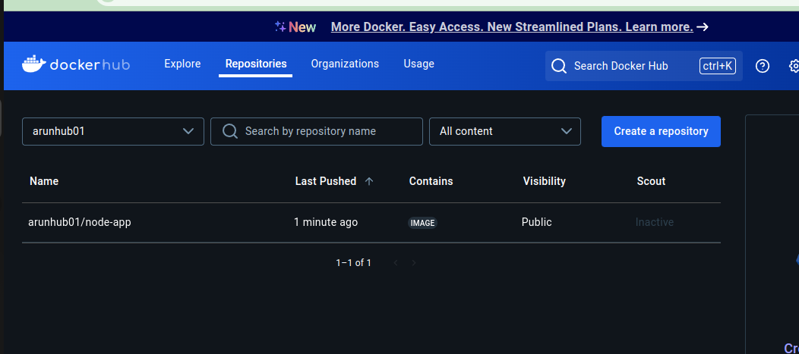

Completed
—--------------------------------------------------

